GEOG 475

Lab 2

Cameron Hurst

**Lab 2.1 Screenshots and Questions**

1)

*Show the map of water-well location pattern (1 point).*

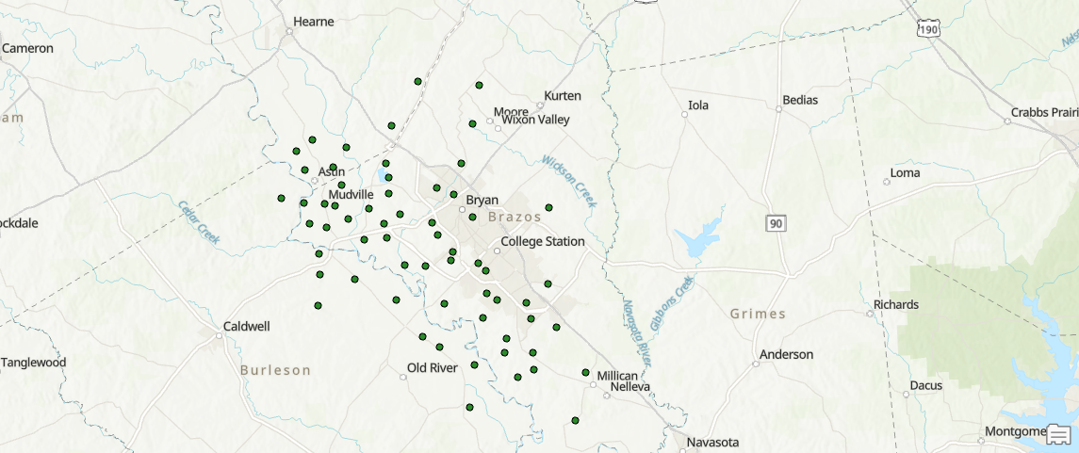

*Describe the water-well location pattern across Brazos County using the metrics that you generated (4 points).*

The distribution of the wells appears to be centered around the Brazos River, which runs from Northwest to Southeast through the area, on the West side of the Bryan – College Station area. After using x bar and y bar, a new layer was created to place a point on the map for the average 2D location of the water wells. This was done by completing calculations on the provided data in excel, then transferring the data into ArcGIS Pro. Once the data was in ArcGIS pro, a table was created to store the data, and geoprocessing was used to place the point where the average of the well locations was placed. As expected from the statement above, the location of the average of the wells was West of the center of the Bryan College Station area, closer to the Brazos River. The excel file will be submitted with this document to show the calculations. The red triangle on the map below marks the point of the average of the locations of the wells.

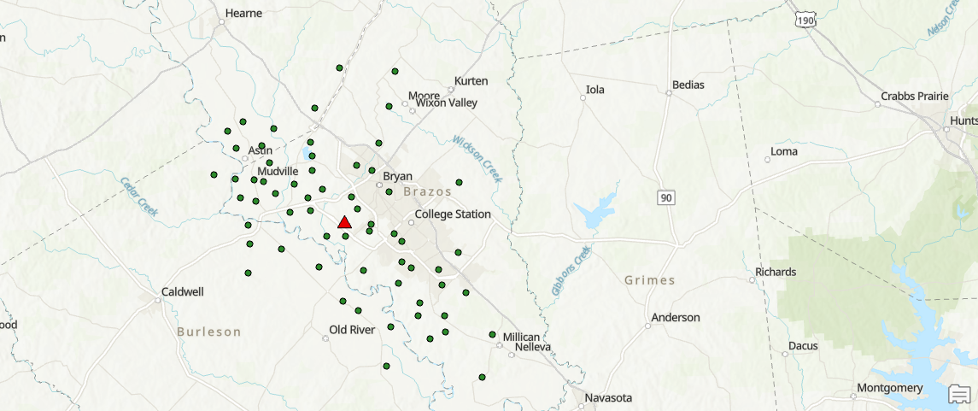

2)

*Show the map of water-well location pattern for contaminated wells (2 points).*

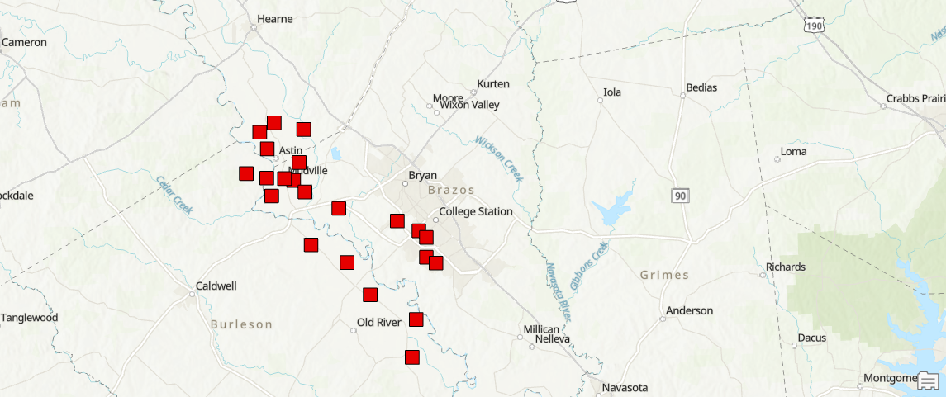

*Describe the water-well location pattern for contaminated wells across Brazos County  (4 points).*

The location of the contaminated wells appears to be the wells closer to the Brazos River, this would make sense, because the Brazos River is likely to carry contaminates from water pollution upstream, as well as the possibility of contaminates flowing into the river directly from the Bryan - College Station area. These wells specifically are down terrain from the populated areas of the region. The same analysis was completed of the contaminated wells that were completed for all of the wells, and the average point is located on the RELLIS campus, which is closer to the Brazos River as well. The average location for this point is denoted by a black circle, where the individual contaminated wells are marked by red squares.

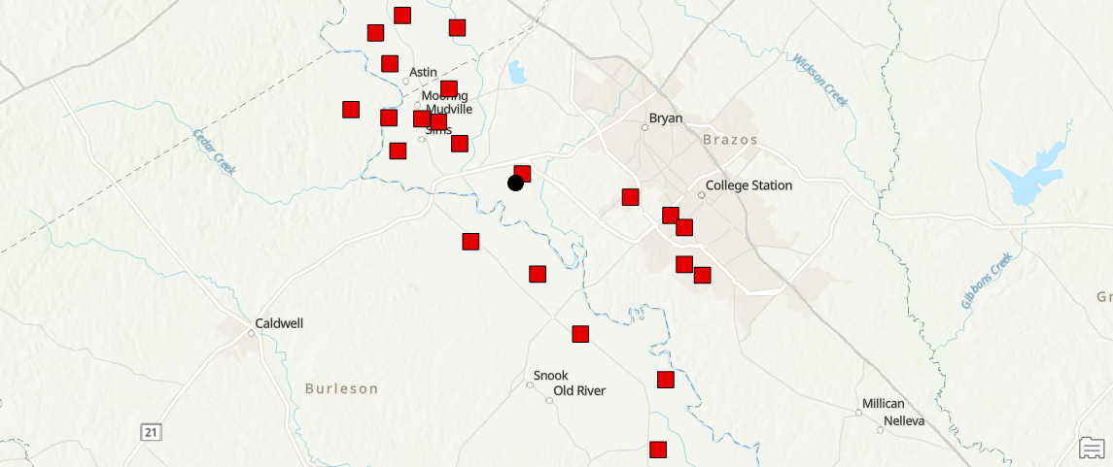

*Compare and contrast the total distribution pattern versus the contaminated pattern  (3 points).*

The total distribution compared to the contaminated distribution appears to be quite similar. The contaminated point is however closer to the Brazos River, which agrees with the hypothesis. The majority of the wells are located near the river, however when looking at the contaminated wells it is quite clear that the distribution of the contaminated wells is closer to the Brazos River. When looking at the points of the wells as a whole, compared to the contaminated wells, there is not a single contaminated well Northeast of highway 6, which is on the other side of Bryan – College Station from the Brazos River. Below, there will be an image of the two average 2D locations of the points, again the red triangle is the average 2D location of all the wells, where the black dot is the average of the contaminated wells.

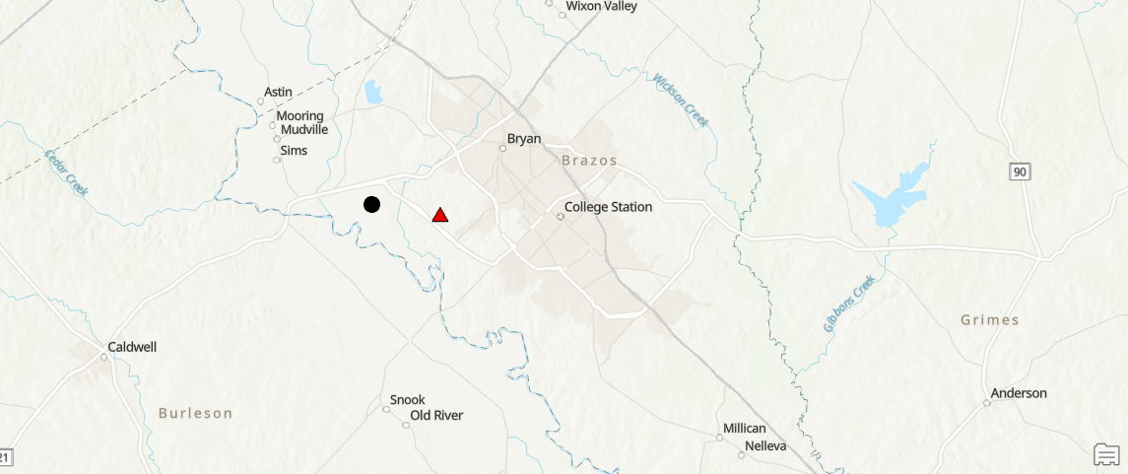

The calculation / formula for the calculations that produced this result are listed below.

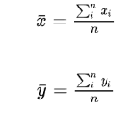

3)

*(4 points). Does the contamination pattern reflect any potential sources of pollution (hint: examine the satellite imagery and examine the land use patterns with their maps)?*

After reviewing the satellite imagery, there are two conclusions that make sense as it pertains to water contamination. The first being that the Brazos River is the source of the pollution, based on the Brazos Rivers proximity to the contaminated wells compared to the other wells. The second is that the contaminated water wells are mostly impacted by agriculture in the Brazos River Basin. The satellite imagery shows that the majority of the contaminated wells are in a tan/brown colored field where one should assume that crop growth takes place.

**Part 1 Calculation Results:**

The coordinate format on calculate geometry was used as “Same as input” for that reason some of the numbers may be off, however the use of the formulas can be seen in the excel file submission.

x Bar  
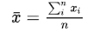

Wells : 747110.5

Contaminated Wells : 741862.3906

In excel :

=SUM(B3:B64)/62

y Bar

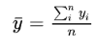

Wells : 3391075

Contaminated Wells : 3391758.127

In excel :

SUM(A3:A64)/62

Average d Bar

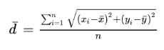

Wells : 12863.04856

Contaminated Wells : 11744.75

In Excel :

For Average d Bar

=AVERAGE(C3:C64)

For a single d bar

=SQRT((B4-D$3)^2+(A4-E$3)^2)

Std. Distance

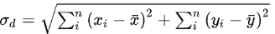

Wells : 111537.253

Contaminated Wells : 59724.2067

In excel :

=SQRT(J2+J4)

Where J2 is sum std latitude and J4 is sum std longitude

**Lab 2.2 Screenshots and Questions**

1)

*(8 points). Compare and contrast the point patterns derived from the point density tool with different neighborhood shapes (show the maps)  (4 points)*

Kernel :

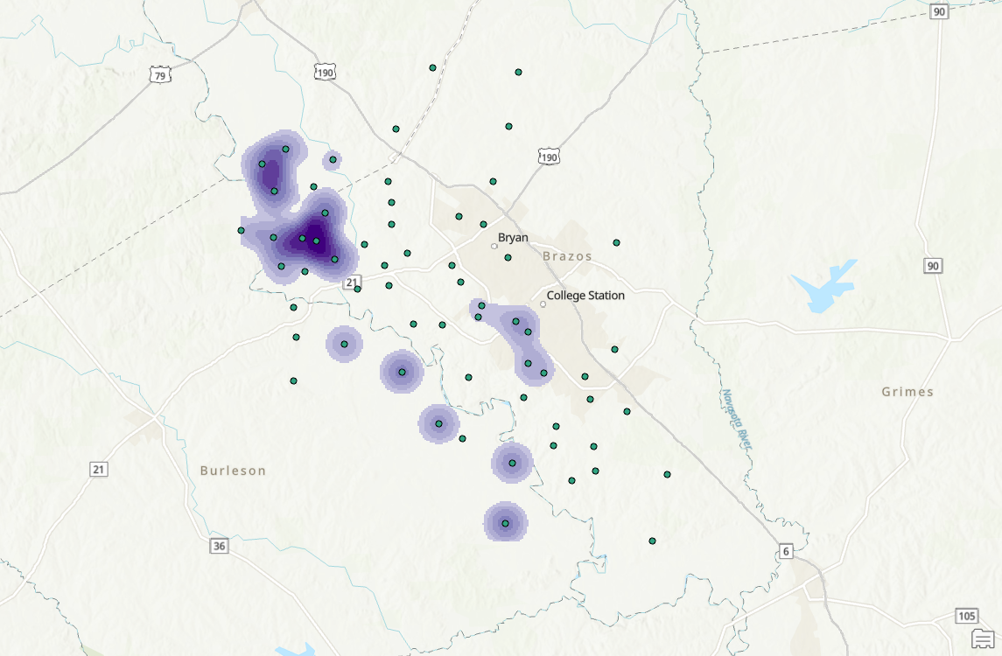

Point Density :

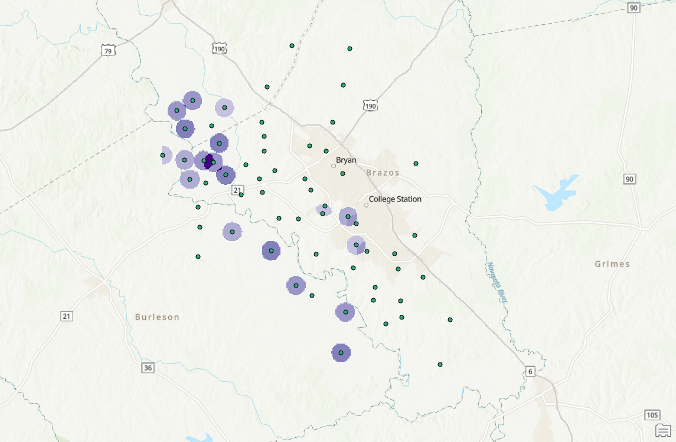

Point density and Kernel are quite similar as it pertains to the wells further away from each other, where there is a high density of points however, there is a visible difference between the two-point pattern analysis tools. The point density method uses darker circles around the points to symbolize a higher ppm value at the specific well. Where the kernel method creates somewhat of a heat map which shows, and highlights areas that have a high density of nitrate contamination in wells.

*Does the shape of the neighborhood influence the spatial distribution of contamination?  (4 points)*

The shapes do influence the spatial distribution of the contamination. There are eleven points in the northwest corner of the map that create one large area that shows nitrate contamination in the wells. The shapes when looking at satellite imagery can confirm a point made in part 1 of the lab, that the nitrate contamination seems to be primarily centered around the Brazos River Basin, where there is plenty of agriculture, and farms.

2)

*(12 points). Compare and contrast the point patterns derived from the kernel density tool with different output cell sizes and varying search radius. Does the*output size*influence the spatial pattern that is obtained (be sure to keep the radius constant when you compare results) (show the maps) (4 points)?*

The map with the changed output cell size is below. When changing the output cell size to ~250 (From ~170) the output is different from the original map. However, the overall result still remains unchanged. The overwhelming majority of nitrate contamination in wells resides in the fields that are on or near the banks of the Brazos River. When changing the output size, the main hotspot for contamination moved towards the Northwest after using the kernel density tool, and the previous hot spot turned into what looks similar to the point density map. In conclusion, yes, the output size did influence the spatial pattern.

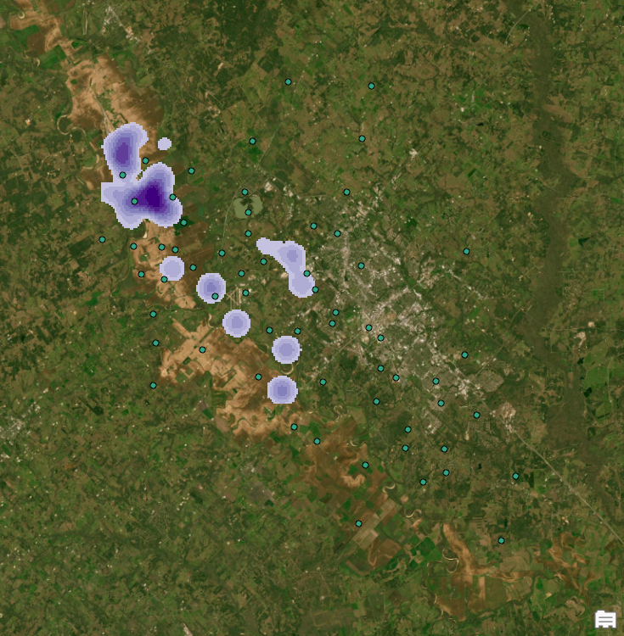

*Does the* search radius*influence the point-pattern distribution (show the maps) (4 points)?*

The map showing the new point pattern analysis is below. After changing the radius to ~2000 (from ~1400) the points look much more pixilated. There is also more overlap between the different points representing nitrate contamination in the wells. The change in radius did change compared to the original point pattern map, it made the points larger with more overlap. There were new points that popped up with high nitrate contamination. There was still the majority of the contamination in the fields alon, and near the Brazos River. In conclusiton, the radius change in the point density analysis did change the point-pattern distribution.

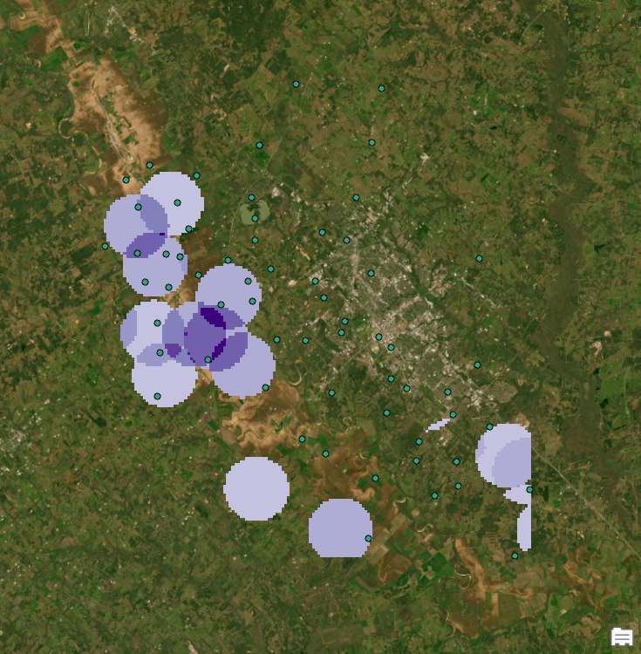

*How would you determine which cell size and distance to use to accurately depict potential hotspots of groundwater contamination (4 points)?*

Based on the previous results of manipulation, the best approach would be to test a middle, upper, and lower point for analysis, and pick the result with the output that makes the most sense. For the Kernel, and Point Density tools, the output that was run by default had an output that not only looked better, but also provided a visual that made sense. Specifically on the Point Density tool, the default radius looked much better whereas the increased radius looked pixilated as well as had large dots that had not shown up in previous runs of analysis.

3)

*Compare and contrast the results from the point density and the kernel density tools with the screenshots of maps (4 points).  Do they present similar or different point-pattern results? (4 points)*

Point Density



Kernel



The kernel density tool and the point density tool both provided similar point pattern results. Both versions of analysis pointed towards high contamination on the northwest portion of the map, centered around the Brazos River Basin where there is plenty of agriculture and farming. Both forms of analysis present themselves differently, but the theme of the results were quite similar. Kernal does a better job in this example of showing the hotspots of nitrate contamination, whereas dot density looked a little less organized when presenting the data.

4)

*Finally, interpret your point-pattern analysis results. What do the results suggest about the sources of groundwater contamination in Brazos County? (4 points) Can these patterns be attributed to natural processes or anthropogenic factors? (4 points)  Be specific in terms of what you hypothesize is the cause of the groundwater contamination.  Be sure to utilize additional spatial data to help verify your interpretation (e.g., satellite imagery or DEM).*

Initially, Ithought that the groundwater contamination in the Brazos valley could be mostly attributed to the population center of the area, Bryan – College Station, however, after utilizing satellite imagery, the majority of the groundwater contamination in the area can be attributed to the Brazos River, and, more importantly, the farming and agriculture in the Brazos River Basin. The contaminants could be attributed to crop growing practices including pesticides. I think the results can be attributed to both natural and anthropogenic factors, such as over exploitation, species translocation, or other processes. In conclusion, the contamination can be attributed to many different factors, however it is more than likely that the reason for groundwater contamination can be mostly attributed to agriculture and farming.

**Lab 2.3 Screenshots and Questions**

1)

*Show the map of results based on the spectral data (2 points). What information is generated when the metric is used on the spectral data (2 points)?  What does it effectively highlight (2 points)?  Does the nature of the information change when you utilize the metric over a larger area (2 points)?*

Spectral 3x3 m

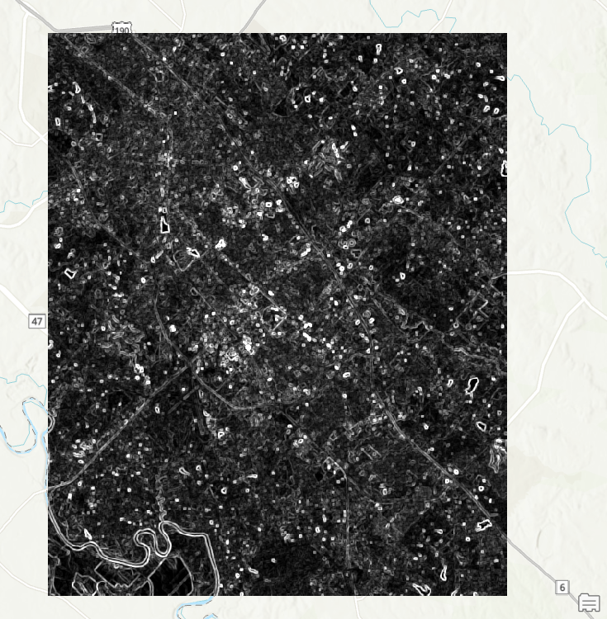

Spectral 11x11 m

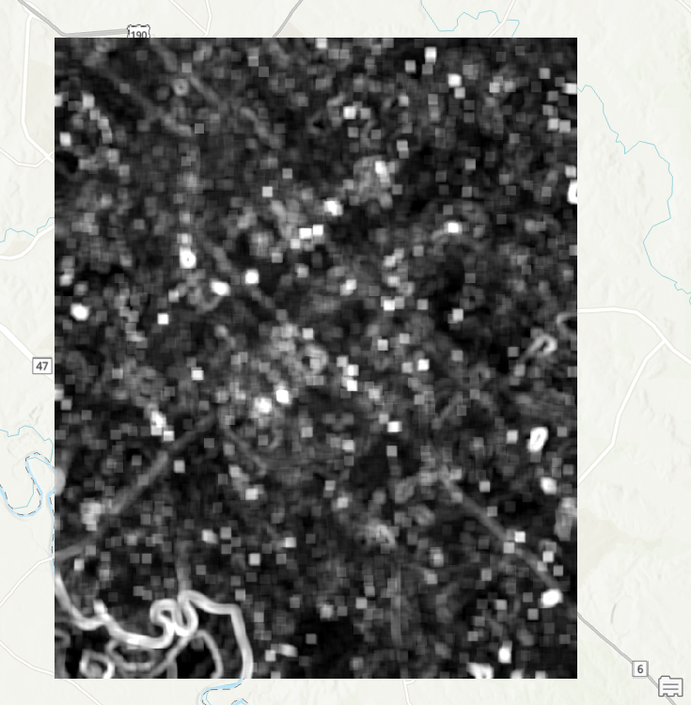

The metric used in the focal statistics analysis was standard deviation, which would be used to visualize, or measure the variation in spectral values. This specific form of analysis can visualize either the homogeneity, or heterogeneity of a landscape. The analysis highlights waterways very well, specifically in the (11x11 m) analysis. The Brazos River can be seen in the Southwest portion of the map. In the (3x3 m) analysis, roadways, riverbanks, ponds, and buildings stand out in the imagery. The nature of the information would most certainly change over a larger area. For the area of analysis in this example, the things that are being pointed out are smaller scale, like a riverbank, or the roof of a building. However, if this were to be a larger study area, it would highlight cities, lakes, even oceans. An (11x11 m) analysis may even be more suitable for a larger area than a (3x3 m) analysis. It must also be mentioned that a larger area would take much longer in processing time, as well as much more computer storage.

2)

*Speculate on what you think this information could be used for (e.g., a particular application, mapping, assessing the landscape) (4 points)?*

This specific information is good for seeing the relation of the Bryan – College Station area and its proximity/relationship with nearby landforms and rural areas. This kind of analysis highlights water features, ponds, rivers, and more very well, while also highlighting buildings and roadways in the area. This data could be used to present either differences or similarities over a certain portion of an area, being that it was a standard deviation analysis as well.

3)

*Show the map of results based on the spectral data (2 points).  What information is generated when the metric is used on the DEM (2 points)?  What does it effectively highlight (2 points)?  Does the nature of the information change when you utilize the metric over a larger area (2 points)?*

DEM 3x3 m

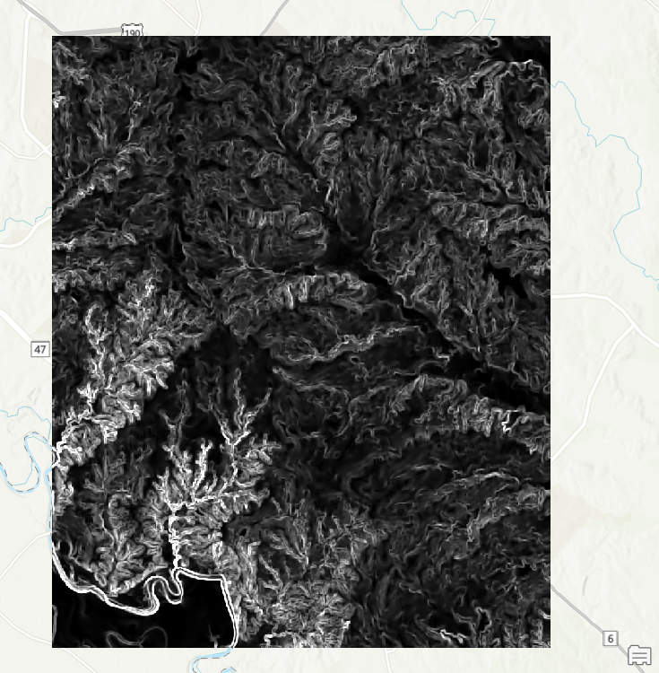

DEM 11x11 m

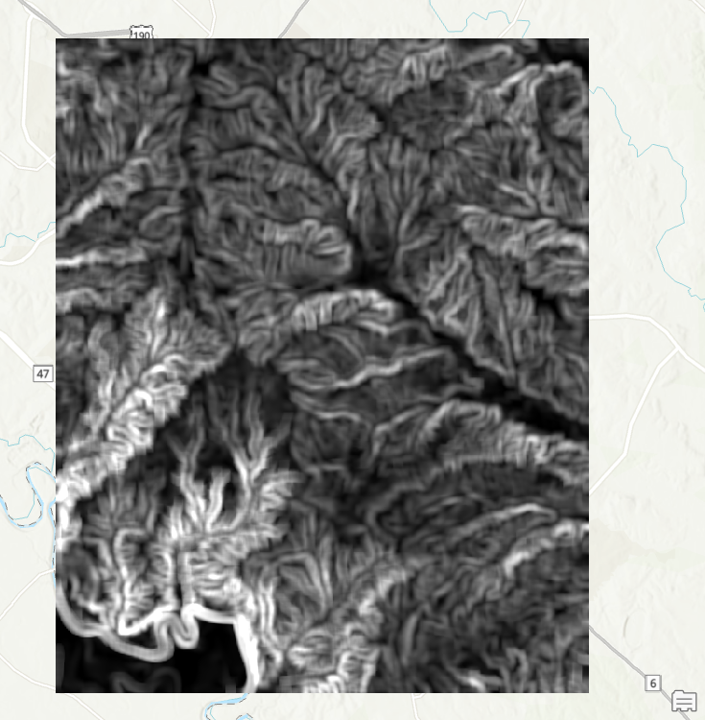

DEM stands for digital elevation model, which means that a DEM would best characterize elevation, after analysis using standard deviation, the result shows the variability in elevation in this area. It also highlights the direction of water flow in different directions, the Brazos River can again be seen quite clearly in the Southwest corner of this image, but what stands out the most is that for an area like College Station, one would not assume there would be this much variability in terrain. The DEM after the standard deviation analysis looks like streams flowing down a mountain. While the area of analysis is not a mountainous area, that is exactly what is being shown, creeks, and the direction of waterflow into the Brazos River, or the Navasota River. If the metric were used over a larger area, more of the same would be seen, with more variability in the results, as well as different directions of water flow. As mentioned in question 1, the (11x11 m) width and height may be better for larger areas of analysis.

4)

*Theoretically, what topographic property should the metric characterize (2 points)? Can you provide any evidence for your answer (2 points)?*

Theoretically it would characterize waterflow, if the DEM were to be larger, one could be able to tell the drainage divide between the Brazos River and the Navasota River, but as can be seen with the data provided, much of the water flow from this DEM appears to be flowing towards the Brazos River

5)

*Speculate on what you think this information could be used for (e.g., a particular application, mapping, assessing the landscape) (4 points).*

This kind of mapping could be used for many different reasons, but one specific reason is coming to mind. Flood analysis. Insurance companies, homebuyers and citizens could use this information for insurance plans, disaster preparedness, as well as homebuying purposes. This data would be much more useful for these specific reasons in coastal towns or cities such as Houston or New Orleans, but nowhere is immune from the potential of flooding. This information could also be used to analyze erosion patterns in the landscapes, especially in areas closer to the Brazos River.

**2.4 Screenshots and Questions**

*Did your two samples (semivariograms) accurately depict relatively high versus relatively low spatial variation in spectral variation (2 points)?  How do you know this?  Provide evidence based on your interpretation of the semivariograms with the screenshots of your results (4 points).  Was there any significant scale-dependent variation that is related to structural or environmental conditions, or was the variation relatively constant with scale (lag distance) (4 points)?*

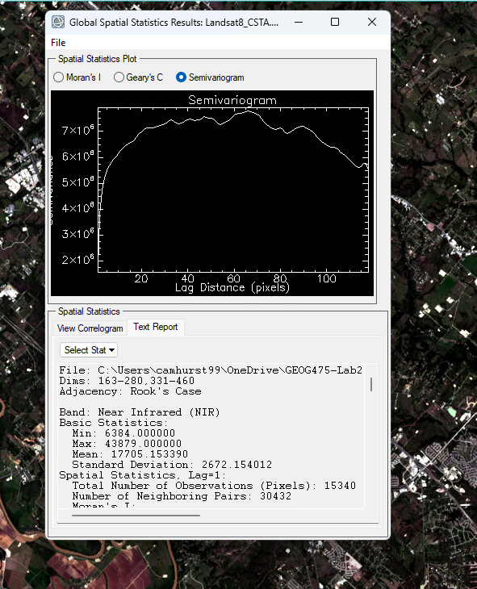

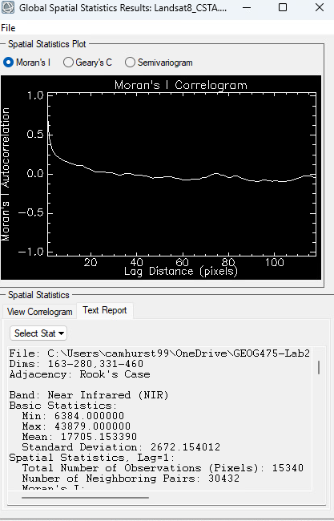

The variability was shown in both the Moran and Semivariogram, the area that was up for analysis covers both rural and arguably an urban landscape, covering the fields of West campus, to the high rises of the Northgate district. So, both the high and low variability was shown in the analysis. Looking at the Moran and Semivariogram, it can be determined that there was high and low variability by looking at the chart, particularly in the Semivariogram. There was certainly variation over the lag distance, the variation was not constant with the scale.

2)

*Could you find geographic areas with greater or less spatial variability (provide the screenshots) (4 points)?  How did these compare to your initial sample sets (provide the screenshots) (4 points)?*

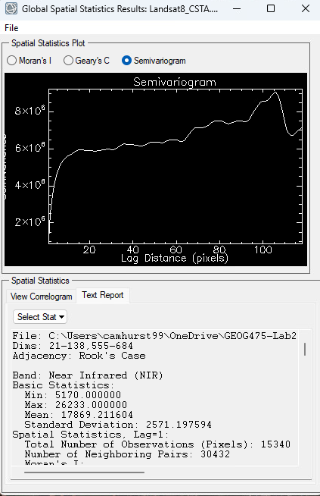

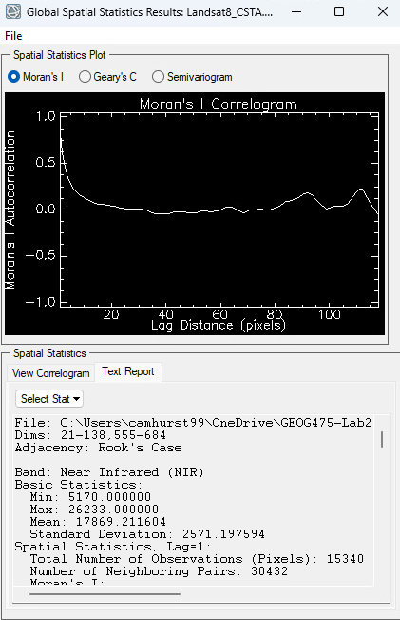

The area that I found with more variance was on the Southwest corner of the map near the Brazos River, the variability in both the Moran and Semivariogram were both higher. The variation was also less constant with the lag distance. This makes sense because in the area observed, there are farms, agriculture, housing developments, a river, and a floodplain that were all analyzed.